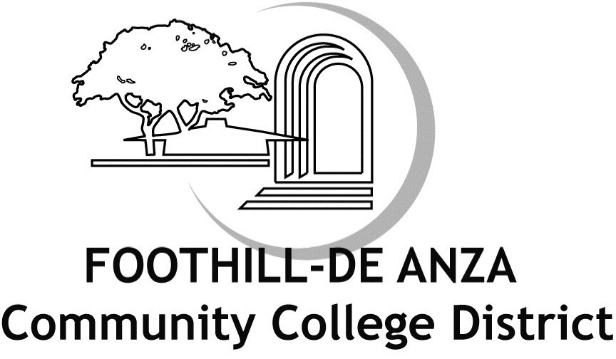

Book Administrative Procedures

Section Chapter 4 - Academic Affairs (including former Article 6 - Instruction and Curriculum) Title Remedial Coursework (formerly Remedial Limit Waivers)
Code AP 4222 (formerly BP 6050)

Status Up For Revision

Legal Education Code Section 78213
California Code of Regulations, Title 5, Section 55035 ACCJC Accreditation Standard II.A.4

Adopted September 21, 1992

Origin Legally required - CCLC update to to reflect an amendment to Education Code Section 78213 that places certain limits on enrolling students in remedial English or mathematics coursework. Replace outdated language from 1992 with CCLC recommended language. APM revision 2/20/19.

Office Chancellor's Office

Upload February 8, 2015

It is the policy of Foothill and De Anza Colleges not to grant waivers to the 45 remedial quarter unit limit. This policy is subject to review based on future experience.

(CCLC NOTE: This procedure is legally required. Local practice may be inserted here, which must include the following:)

Per California Code of Regulations, Title 5, Section 55035, “remedial coursework” refers to nondegree-applicable basic skills courses, which will henceforth be referred to as "basic skills coursework" in this document. Foothill De Anza CCD does not support labelling classes as remedial due to the implications of student deficiency tied to this label but is using this designation in this document to match the language of Title 5.

Remedial coursework consists of pre-collegiate basic skills courses.

A student’s need for remedial basic skills coursework shall be determined using appropriate assessment instruments, methods, or procedures.

No student shall receive more than 45 quarter units for remedial coursework. A student who exhausts this unit limitation shall be referred to appropriate adult noncredit education services.

Per California Code of Regulations, Title 5, Section 78213, no student shall be required to enroll in remedial basic skills English or mathematics coursework that lengthens their time to complete a degree unless placement research that includes consideration of high school grade point average and coursework, shows that those students are highly unlikely to succeed in transfer-level coursework in English and mathematics. A student may be required to enroll in additional concurrent support, including additional language support for English as a Second Language students, during the same semester term that they take a transfer-level English or mathematics course, but only if the college determines the support will increase their likelihood of passing the transfer- level English or mathematics course and will not result in disproportionate impact.
The college shall minimize the impact on student financial aid and unit requirements for the degree by exploring embedded and low or noncredit support options.
A student who successfully completes remedial basic skills coursework or who demonstrates skill levels which assure success in college-level courses may request reinstatement to proceed with college level degree applicable coursework.

Students enrolled in one or more courses of English as a Second Language and students identified as having a learning disability are exempt from the limitations of this procedure.

Students who demonstrate significant, measurable progress toward development of skills appropriate to enrollment in college-level degree applicable courses may be granted a waiver of the limitations of this procedure.

College catalogs shall include a clear statement of the limited applicability of remedial basic skills coursework toward fulfilling degree requirements and any exemptions that may apply to this limitation.

Approved 9/21/92

